**How to install Jacoco on Eclipse**

**Manual Download and Installation**

For manual installation please [download](https://www.eclemma.org/download.html) the latest EclEmma release. Unzip the archive into dropins folder of your Eclipse installation and restart Eclipse:

<your eclipse installation>/

+- dropins/

+- eclemma-x.y.z/

+- plugins/

| +- ...

+- feature/

+- ...

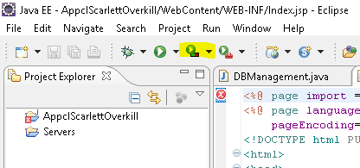

**Verification**

The installation was successful if you can see the coverage launcher in the toolbar of the Java perspective:

(**THIS DOCUMENTATION IS STILL IN PROGRESS**)